Case 5-Asia-China-Hongshan-Cicada Boar Origins-***Xinglongwa***

The symbol of the Cicada-Boar is found in the Early Neolithic site of ***Xinglongwa (****6,200- 5,400 BCE* ***)in the Chifeng area on a ceramic vessel***  and suggests a basis for ***the later Neolithic Hongshan culture symbolism of the Cicada-Boar,*** which was later identified as the Hongshan Pig Dragon.

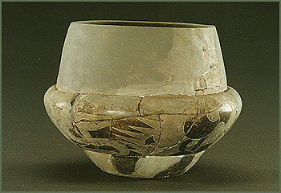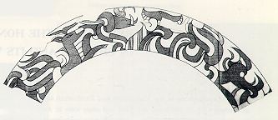

Neolithic Xinglongwa ceramic bowl with roll-out image of designs showing placement of the cicada-boar in the upper center with its curvilinear tail. After <http://www.pitt.edu/~chifeng/pottery/Zhaobaogou4.jpg>

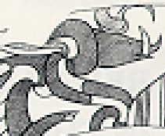

Enlarged image ofthe cicada-boar with its curvilinear cicadan body and boar’s head.

The Xinglongwa and Zhaobaogou cultures were identified during the 1980’s (Xu 1989) which yielded the earliest evidence in the area known so far for permanent habitations, jade working, ceramic production, and the domestication of wild boars, which were placed in graves beside their owners.

“The relics of Xinglongwa Culture are located at a tableland 1.5 kilometers to the southeast of Xinglongwa Village of Baoguotu Township, Aohan Banner, Chifeng, Inner Mongolia. The six rounds of excavations at Xinglongwa relics have discovered ruins of 170 houses and more than 30 graves, which took the lead in China in revealing all the traces of habitation, including ditches, ruins of houses and cave dwellings of the people of a pre-historic tribe.

The evolution of the habitation at Xinglongwa went through three stages. Houses of the first stage are comparatively spacious, distributed in lines from the northeast to the southeast and surrounded by elliptical ditches. Houses of the second stage follow their predecessors in arrangement but with smaller areas; houses of the third stage are disorderly and more densely arranged with still smaller areas, indicating the considerable prosperity of the tribes of Xinglongwa.

The graves of Xinglongwa relics are an essential component of Xinglongwa Culture, and the number and location of these graves suggest that they are related to the sacrificial activities of the people of that time. In one of the graves, we can find that the dead was buried side by side with two pigs, one male and the other female, which leads to our assumption that due to his social status and extraordinary cause of death, the dead was taken by his fellow tribesmen as the object of worship and sacrificial rites so that they could be blessed by certain kind of supernatural power. The pigs buried alongside the dead indicate that the offering of sacrifices to ancestors was combined with those to the preys, and the offering of sacrifice by the inhabitants of Xinglongwa to the spirit of pig is considered to be of the significance of totem worship. The large numbers of bones of deer, pigs and other animals unearthed at the ruins of houses and among the funerary subjects is another proof to the fact that hunting economy was in the dominant position in people's life at that time.

The dozens of jade articles unearthed at Xinglongwa site shows that the people of Xinglongwa were aware of the selection of materials-most of the artifacts were made from pale green, yellowish green, milky white or light white materials, and that they had gained knowledge of polishing and boring. As the earliest genuine jade articles known to us in China so far, the artifacts unearthed at Xinglongwa site have marked the completion of the division of labor of the society, shifted the time of the use of ground genuine jade articles in China to the middle of Neolithic Age as far away as 8,000 years ago, and provided a direct origin for the jade articles of Hongshan Culture.” After <http://www.pitt.edu/~chifeng/pottery/Zhaobaogou4.jpg>